Amanda Bakalarczyk

COSC 2406

Assignment 5

2017-11-04

A)

TITLE {A} (A.asm)

; Crazy art is crazy

; Amanda Bakalarczyk

; Assignment 5

; Problem A

; 2017-11-04

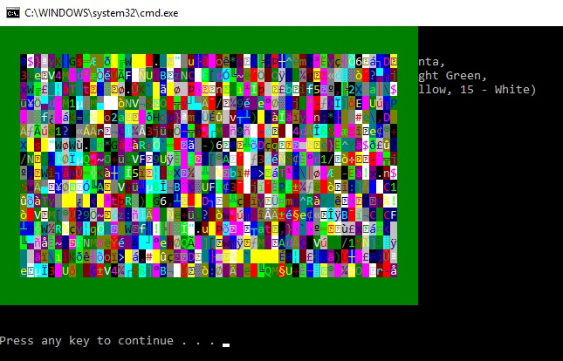

B)

TITLE {B} (B.asm)

; Program populates array with random numbers

; Calls procedure to sum values in array with values between variables j and k inclusive, displays results

;Amanda Bakalarczyk

;Assignment 5

;Problem C

;2017-10-29

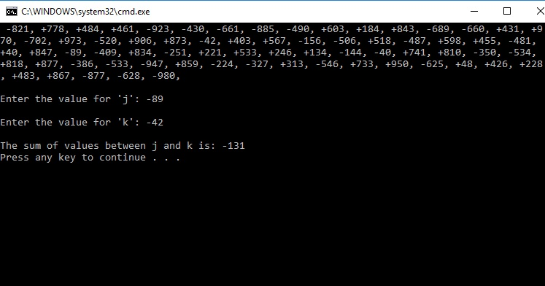

C)

TITLE {C} (C.asm)

; Program asks user for variables: A, B & C. Using these three

; Calculates the following and displays results:

; (A \* B) / (B – C)

; (B / C) – (A \* B)

; 4B / 7C – 3A

;Amanda Bakalarczyk

;Assignment 5

;Problem C

;2017-11-03

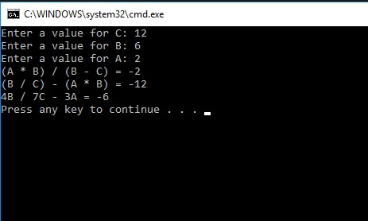

D)

TITLE {D} (D.asm)

; Program asks for value between 0 and 99, displays a message if the number is invalid

; Otherwise calls a procedure to convert unsigned 8-bit binary value in decimal format.

;Amanda Bakalarczyk

;Assignment 5

;Problem D

;2017-11-03

